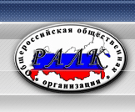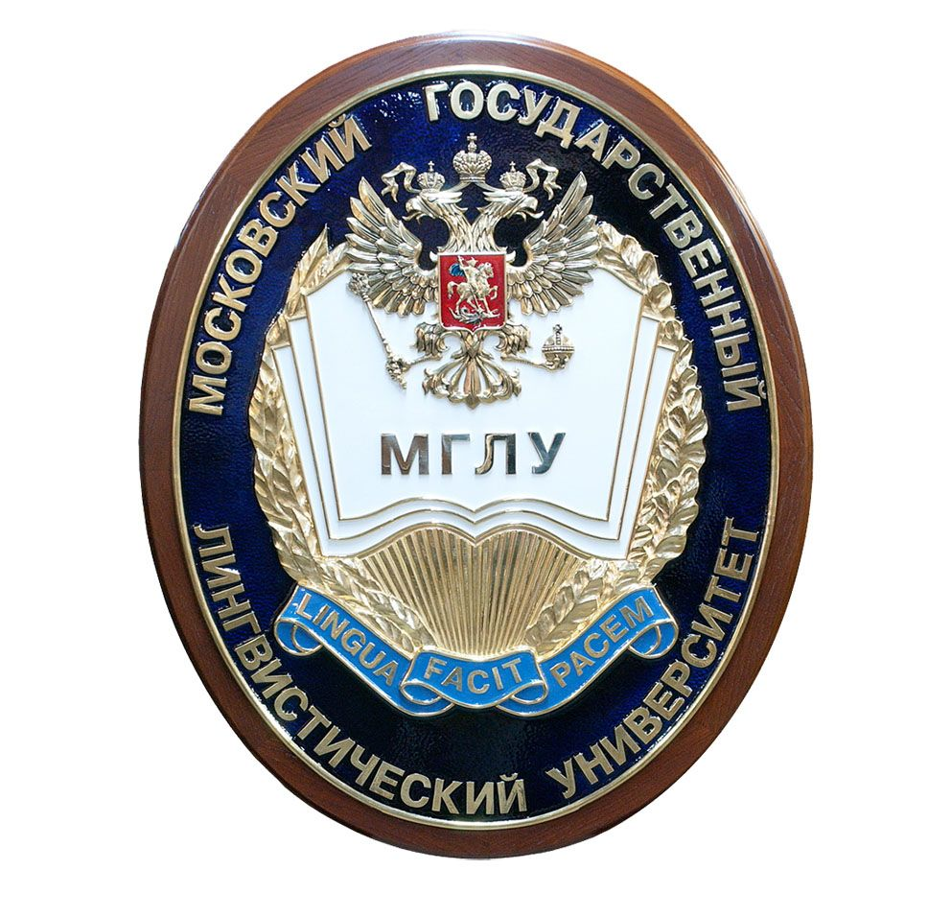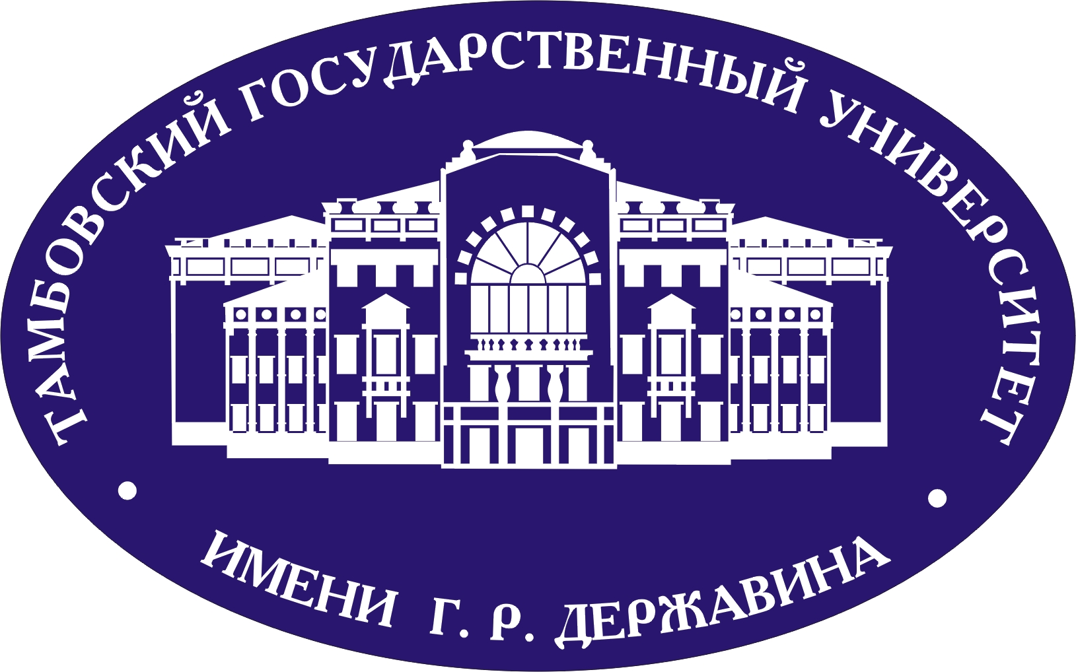 | Russian Cognitive Linguists Association  Moscow State Linguistic University  Institute of Linguistics of the Russian Academy of Sciences  Tambov State University

We are pleased to announce the International Symposium
“Languages, Cultures and Modalities:
New Perspectives for Cognitive Linguistic Studies”
organized by SCoDis - the Centre for Socio-Cognitive Studies of Discourse at Moscow State Linguistic University
(http://scodis.com)

on November 1-2, 2018

The symposium will be devoted to the following topics:

- Cross-disciplinary approaches in present-day cognitive studies
- Theoretical and methodological challenges in cognitive linguistics
- Multimodality in cognition and communication
- Conceptualization and categorization in languages and cultures. Knowledge transfer.
- Cognitive discourse studies: modern trends
- Socio-cognitive studies of language
- Theory of nomination. Imagery in cognition and language.
- Current trends in cognitive derivation
- Cognitive studies of terminology
- Empirical and introspective methods in cognitive communication analysis
- Sign languages from cognitive perspective

November 1, 2018

The first day of the Symposium will feature plenary talks and lectures by well-known domestic and international scholars, as well as the MeMuMo-2018 Workshop, dedicated to methods of multimodal cognitive research.
MeMuMo-2018 will consist of a series of master-classes on new methods of analyzing verbal and non-verbal components of communication (ELAN, eye-tracking, MoCap, etc.). The master-classes will be organized for BA, MA, and PhD students, and will be provided in Russian, English, and French. Students will get a unique opportunity to intensively interact with experts in various fields of cognitive research.

To apply for the master-classes please fill in the application form below and send it to krugstol2018@mail.ru until the deadline of 15.09.2018.
Please, note that the name of the file should indicate the last name of the applicant: ivanov_mol.

Name and surname (in Russian and English)

Home university, department, BA, MA or PhD student

Phone number
Email
How did you learn about the event

November 2, 2018

On the second day of the Symposium the Round Table “Looking Forward: New Perspectives for Cognitive Linguistic Research” will be organized in memory of Elena S. Kubryakova.
The plenary talks focusing on the latest trends in cognitive linguistics will alternate with less formal discussions of the related topics.
Both experienced and commencing researchers are invited to attend the Round Table to listen to V. Demyankov, N. Boldyrev, V. Zabotkina, O. Aleksandrova, M. Kovshova, G. Molchanova, V. Postovalova and other renowned scholars’s talks about the challenges and perspectives of modern cognitive studies.

